CREATOR

* As a creator, I wish that the program or application has an ability in which the user can create his specific account
* 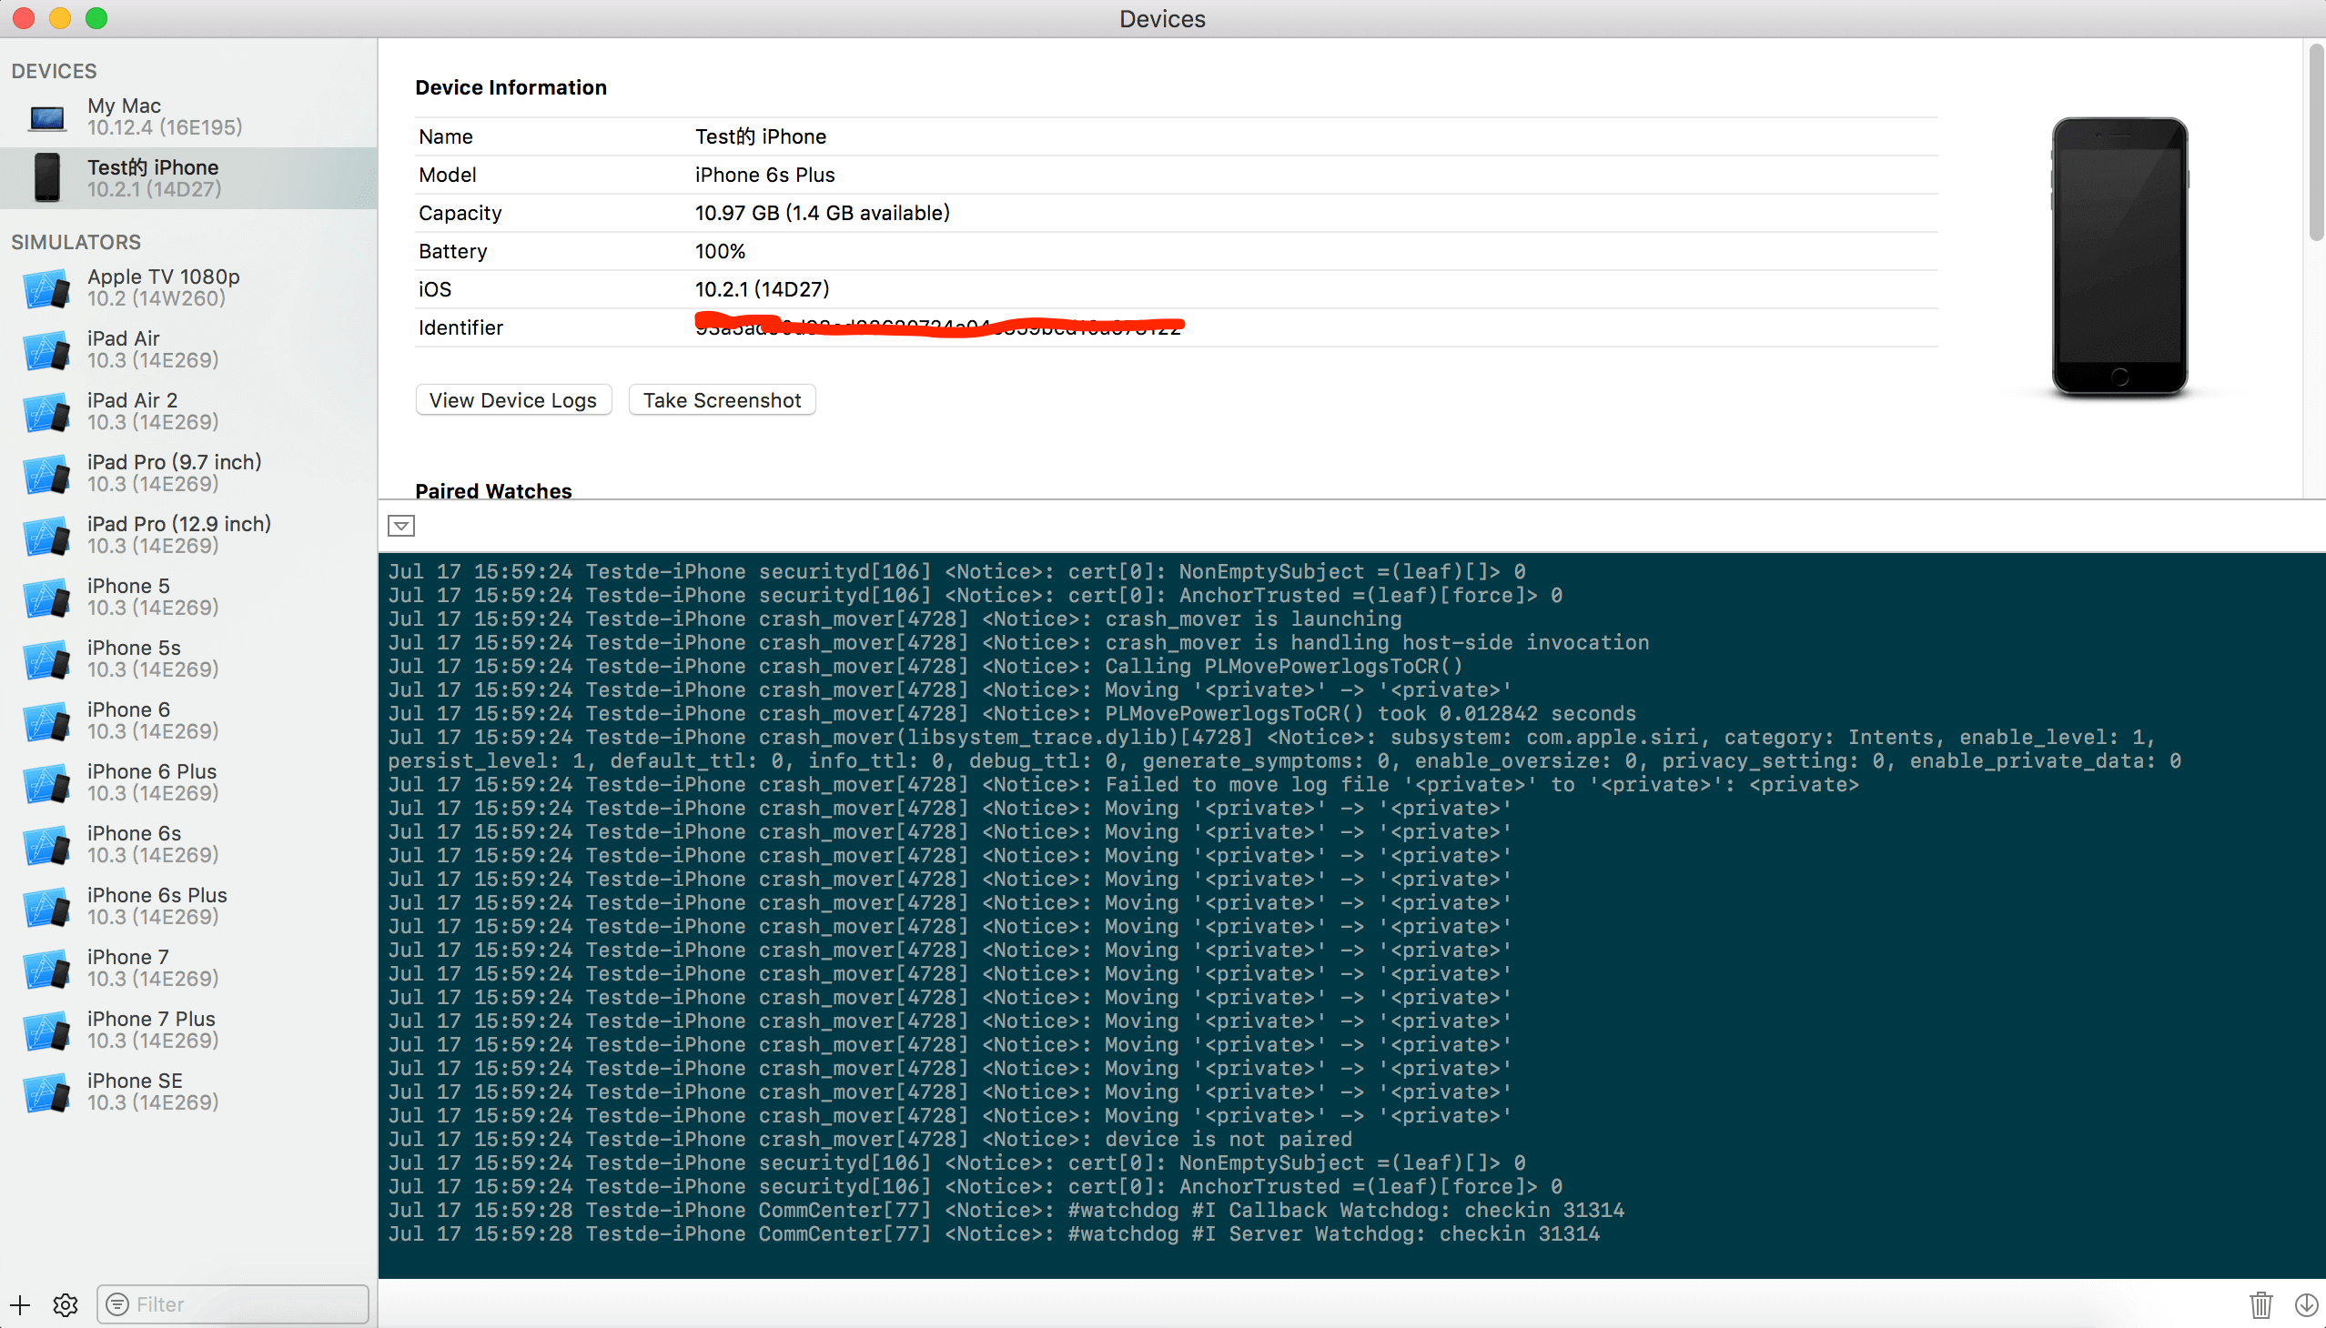
* As a creator, I don’t want users have any issues and try to fix the bugs and glitches

USER

* As a user, I want it to be as simple as possible such that I don’t want to face any issues
* As a user, I want it not to be much complicated and not too confusing
* As a user, I want it smooth and efficiently working application
* As a user, I wish that there was less bugs and glitches because it was a way that I can know my expenditures and 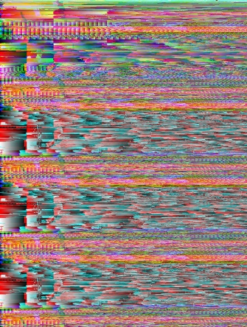be careful about it
* As a user, I wish it was more flexible, allowing me check my process per day, week, month or a year.
* As a user, I wish it would notify me if the expenditures are above a certain level(that I can set)
* 
* As a user, I wish it would not only function well, but also looking good.